# Charles Campbell CS 255 System Design Document

## UML Diagrams

### DriverPass UML Use Case Diagram

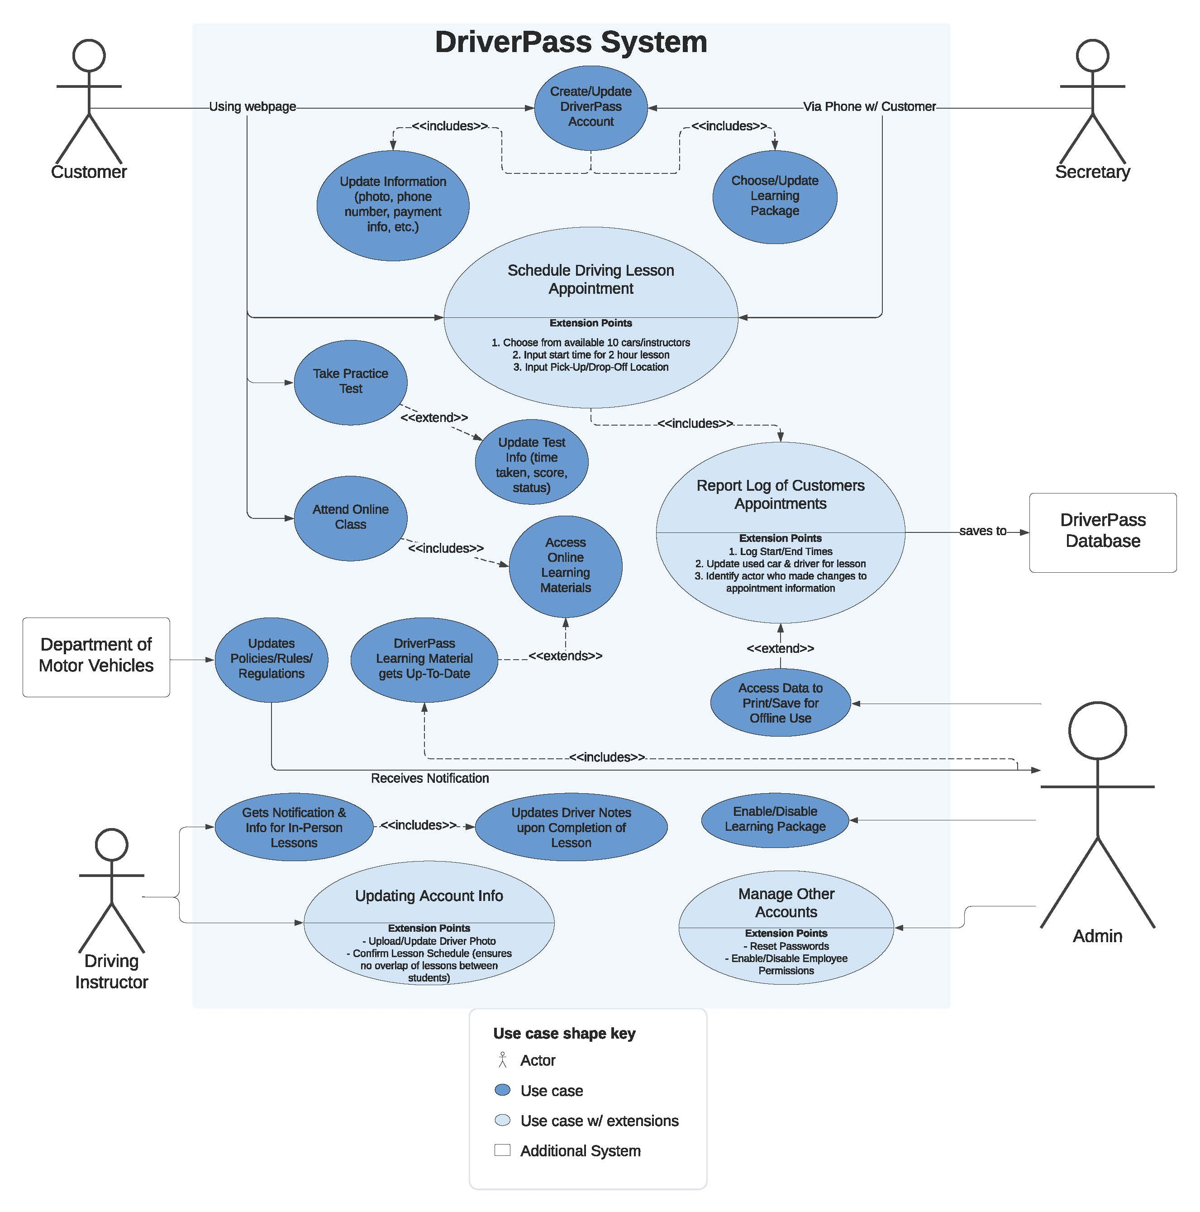

### UML Activity Diagrams

Activity Diagram 1

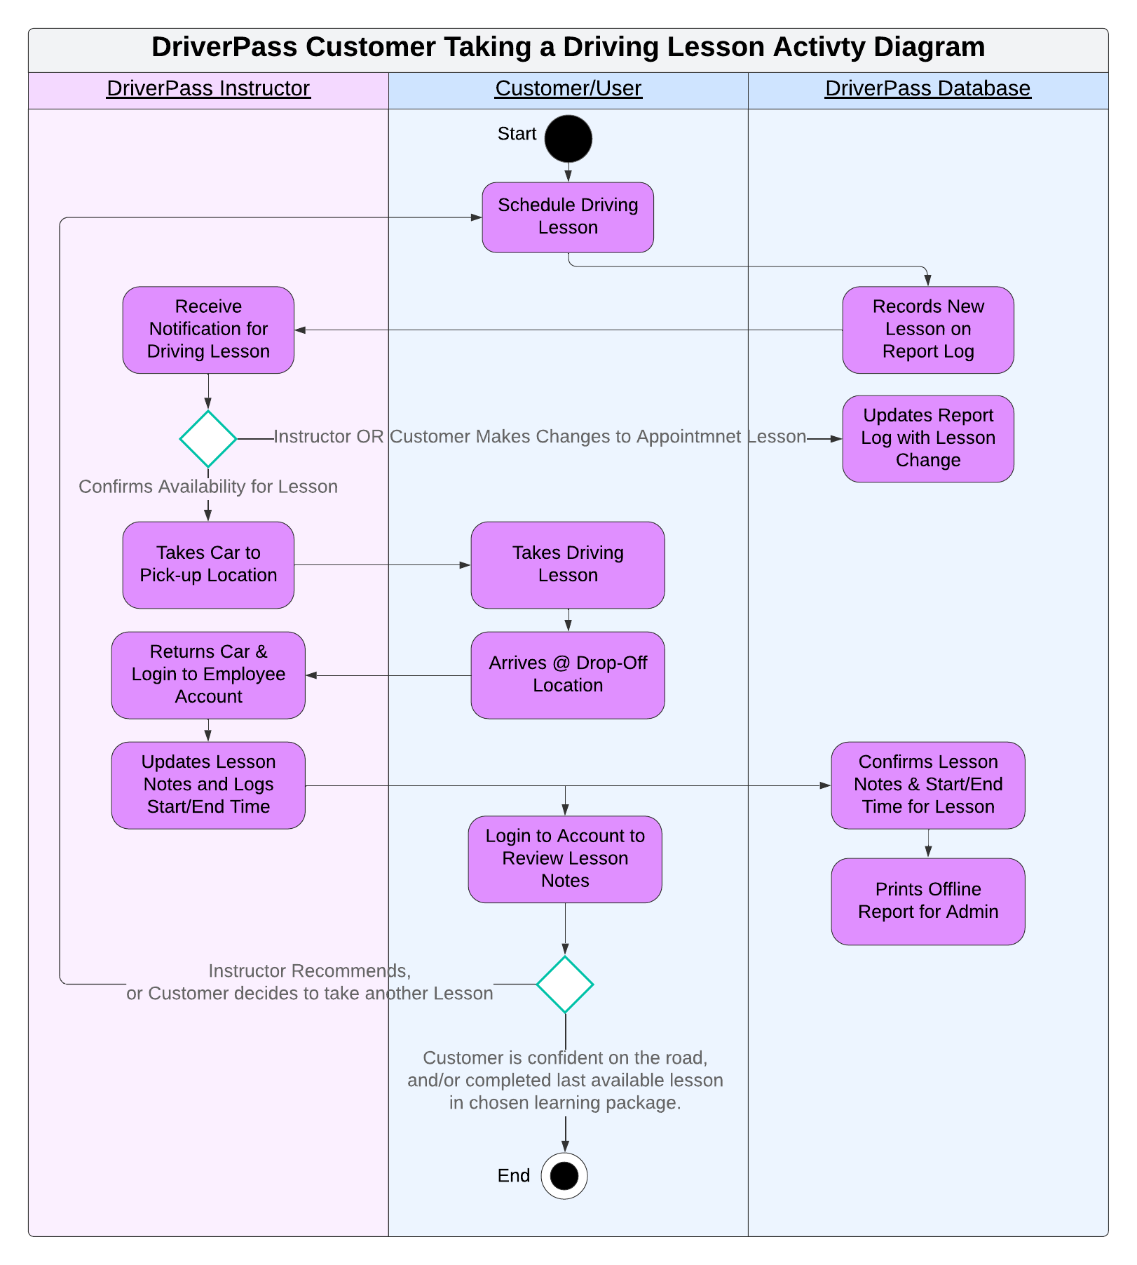

Activity Diagram 2

### 

### *UML Sequence Diagram*

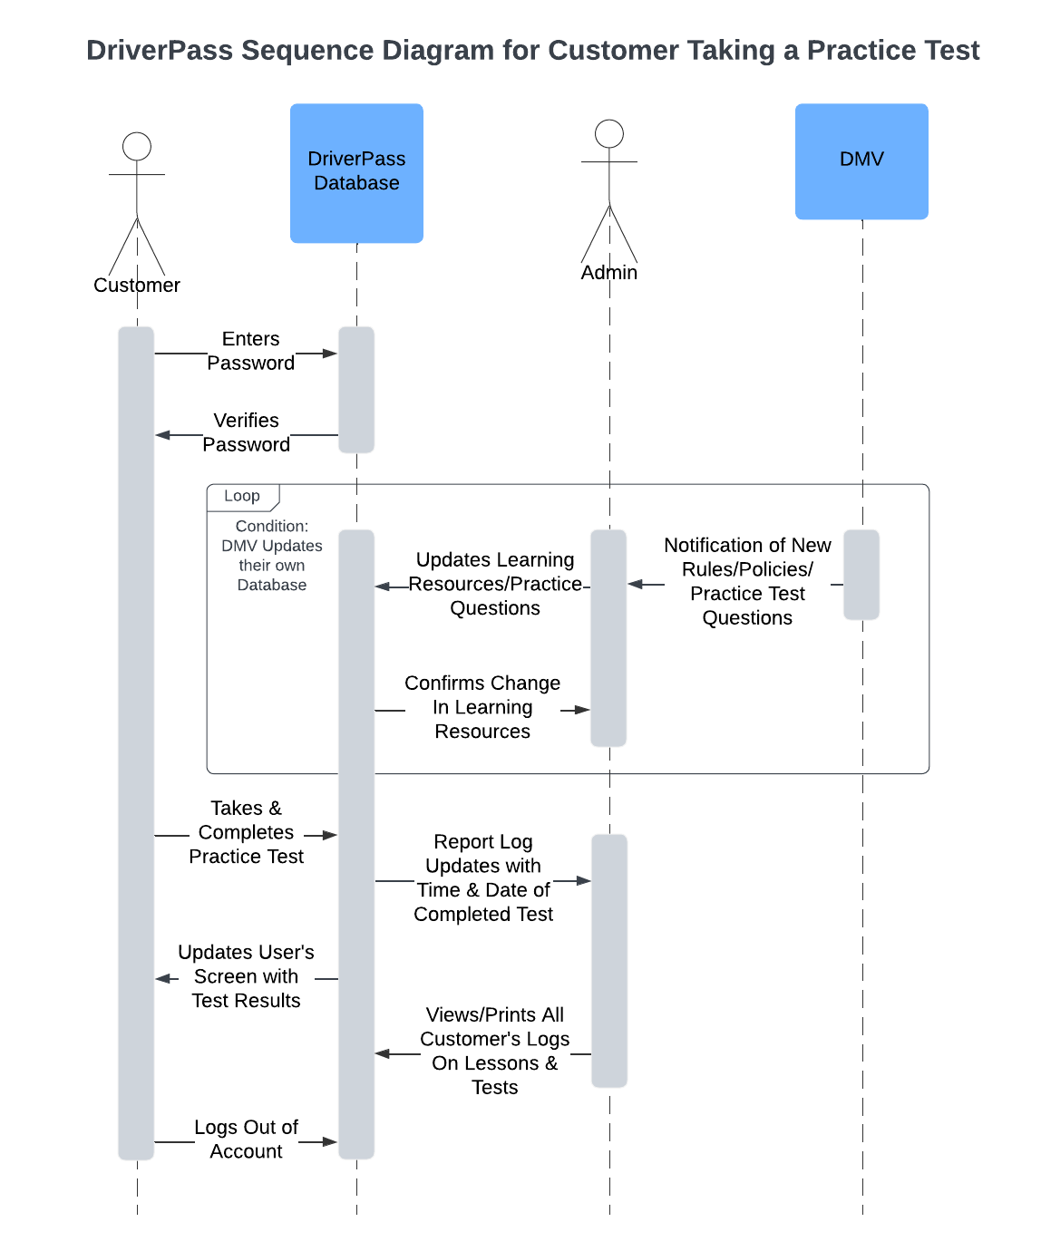

### UML Class Diagram

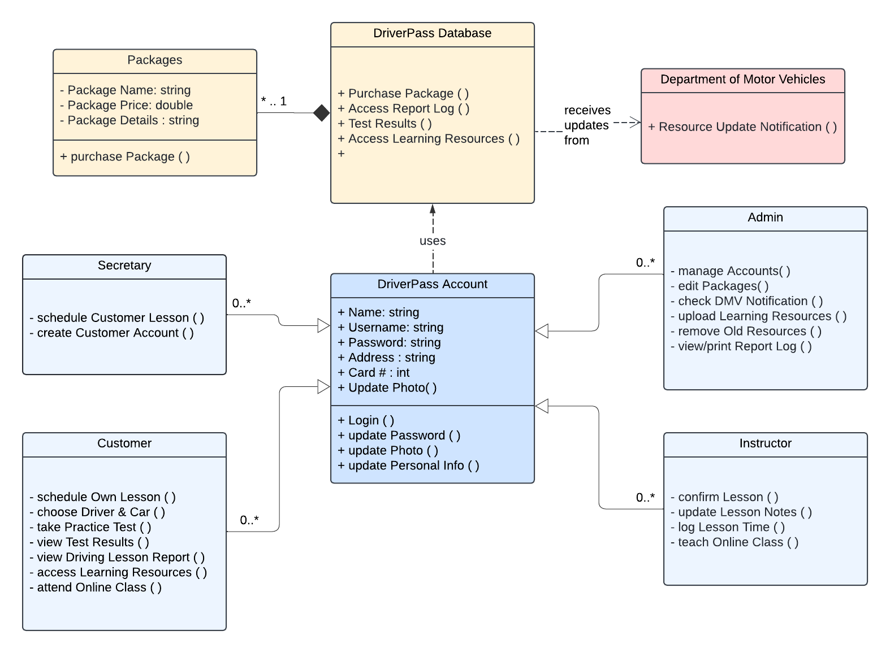

## Technical Requirements

System must be web & cloud based, where customers with any device having internet access can interact with the DriverPass system in order to create accounts, update information (personal and payment), and be able to choose a lesson package in order to: create driving appointments, take online classes & practice tests, and see notes from instructors in order to improve their driving skills.

Hardware required will be a computer(s) with sufficient memory and storage specifications in order to hold customer, employee, and learning resource data so that the DriverPass Database can easily allow students (customers/users) to access learning material, allow employees to update their information and log notes on lessons, and allow admins to manage all accounts & access reports on all lesson logs.

Cloud tools will be required so DriverPass employees can focus on supporting and assisting customers in their vision of providing up-to-date training on driving. Additionally, a tool or infrastructure way of connecting to the local DMV online to ensure that the DriverPass system has the most current and valid rules/policies/resources for students to learn. Infrastructure for the database should allow for ease of access to Admin/DriverPass I.T. lead so they can easily and efficiently update data (passwords for accounts, or learning materials for online classes/tests).